ADVENTURE WORKS · TECHNICAL SUPPORT

Handlebar or Stem Slipping or Misaligned
Steering Document TS-011 Rev. A
Applies to | All Adventure Works models
Difficulty | Beginner
Time required | 10 – 20 minutes
Tools needed | 4 / 5 mm hex keys, Torque wrench, Carbon assembly paste (carbon parts)

Symptoms
- The handlebar rotates down (or up) under pressure.
- The bars are not square to the front wheel.
- The brake levers or shifters twist on the bar.
- A creak from the bar/stem area when pulling on the bars.
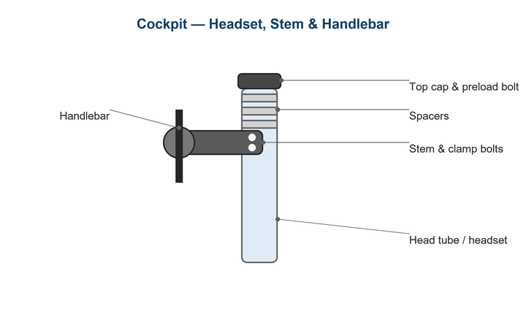
Figure 1. The stem clamps the bar at the face-plate and the steerer at the rear.

Likely Causes
- Stem face-plate or clamp bolts under-torqued.
- Greasy or contaminated clamp surfaces letting parts slip.
- Carbon bar/stem assembled without carbon paste.
- Uneven face-plate gap loading the bar on one side.
- Worn or damaged clamp surfaces.
Safety first
- Loose bars can rotate suddenly and cause a crash — torque correctly before riding.
- Use carbon paste, not grease, on carbon interfaces to prevent over-tightening.
- Never exceed the printed torque on the stem or bar; over-torque can crack them.

Customer Fix — Step by Step
Suitable for home repair with basic tools. Work through the steps in order.
- Loosen the face-plate bolts and align the bar to the desired angle (brake levers usually angled so wrists are neutral).
- Square the stem to the front wheel: grip the wheel between your knees and align the stem, then snug the steerer clamp bolts.
- Tighten the four face-plate bolts in a cross pattern, a little at a time, keeping the gap even top and bottom.
- Torque all bolts to the values printed on the stem (typically 5–6 N·m).
- Confirm an even gap on the face-plate and that the levers don't twist under firm hand pressure.
- Test by pressing down hard on the bars — they should not move.

Technician Reference
Additional checks and adjustments for service technicians and advanced users.
- Degrease clamp surfaces; apply carbon assembly paste to carbon bar/stem interfaces to raise friction without extra torque.
- Inspect the bar clamp area for cracks, gouges, or crush marks; replace if damaged.
- Confirm the bar diameter matches the stem (e.g., 31.8 vs 35 mm) and that shims aren't masking a mismatch.
- Set lever/shifter clamp torque to spec so they slip in a crash rather than break.
- Re-check after a short ride and re-torque if needed.

Torque & Specifications
Fastener | Torque
Stem face-plate bolts | 5 – 6 N·m (even gap)
Stem steerer bolts | 5 – 6 N·m
Brake/shifter clamp | 5 – 8 N·m
Carbon interfaces | Use carbon paste
Tightening pattern | Cross / alternating

Figure 2. Even, correct torque keeps the cockpit secure and protects components.
Pro tips
- An even face-plate gap top and bottom spreads the load and prevents bar damage.
- Mark the bar angle with tape before loosening so you can return to your fit.

When to Visit a Service Center
- The bar or stem clamp is cracked or gouged.
- A carbon bar has slipped repeatedly despite correct paste and torque.
- Bar and stem diameters don't match.
- Levers continue to twist after correct clamp torque.
This guide is provided for reference. Torque values are typical starting points — always follow the specific component manufacturer's instructions. © Adventure Works.

